
GROUP ASSIGNMENT (PART 2)

042024-MAL

Programming with Python

Intake code: UCDF2307ICT(SE)

Subject: Programming with Python

Title of the Assignment: Inventory Management System for PPE – Group 28
Due Date: 2nd August 2024
Name of group members:
Name | TP Number
Jayden Foo | TP073590
Elvan Sea Meng Jin | TP075849
Lai Xiao Chun | TP076509
Kee Genni | TP075968

Table of Contents
1.0 Flowchart - New 3
2.0 Program Source Code with Explanation 4
2.1 Import Modules and Assigning Variables 4
2.2 Main Function 5
2.3 Sign Up Function 6
2.4 Login Function 7
2.5 Read, Write, Append Files Function 10
2.6 PPE File Function 11
2.7 Supplier File Function 13
2.8 Hospital File Function 15
2.9 Distribution File Function 17
2.10 Distribution Hospital Function 20
2.11 Update Inventory Function 22
2.12 Distribute Inventory Function 24
2.13 Update Supplier Function 25
2.14 Update Hospital Function 28
2.15 Track Items Function 30
2.16 Search Distribution Function 31
2.17 Suppliers with PPE Function 32
2.18 Overall Transaction Function 34
2.19 Home Function & Code 36
3.0 Sample Input/Output with Explanation 39
4.0 Screenshots of Text Files 48
5.0 Conclusion 50

1.0 Flowchart - New

2.0 Program Source Code with Explanation

2.1 Import Modules and Assigning Variables
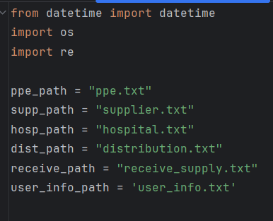
Before beginning the code, three modules are imported into our code, which are the ‘datetime’, ‘os’ and ‘re’ modules. The datetime module allows us to fetch the current date and time, while also performing arithmetic operations with it. Meanwhile, the ‘os’ module allows us to interact with the operating system to perform tasks such as checking paths, manipulating dictionaries and process control. And lastly, the ‘re’ module is used for regular expressions.

After that, variables such as ppe_path, supp_path, hosp_path, dist_path, receive_path and user_info_path are set to their respective text files (“ppe.txt”, “supplier.txt” etc.) to ease the calling process later.

2.2 Main Function
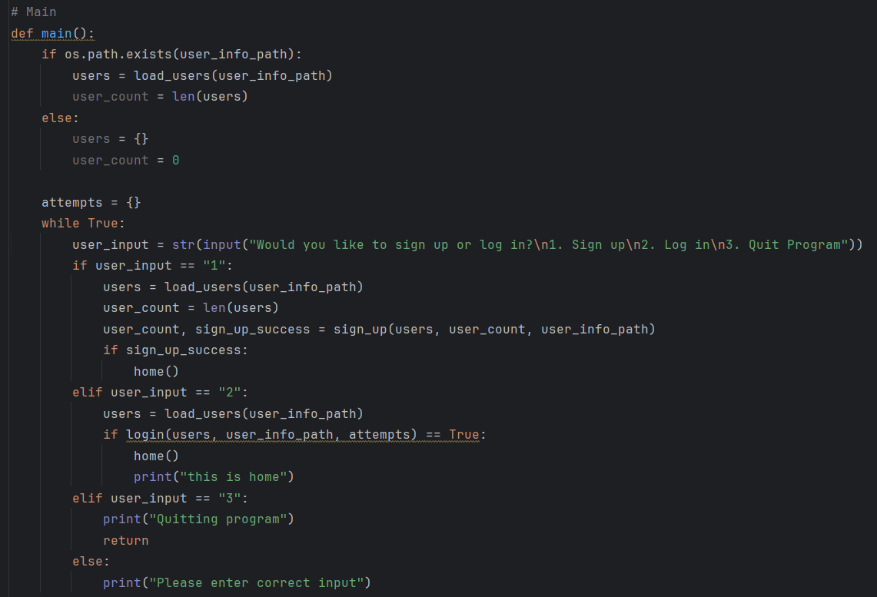
Next, a function main() is defined. This function is the main part and beginning of the code, where users will run the code. The program checks whether the path “user_info_path” which is defined earlier exists or not. If so, the program will check for the number of users which are already registered in the system by checking the text file linked to the path. If “user_info_path” does not exist, the number of users in the system will be set to 0. After that, in a while True loop, the program will prompt the user to sign up, login or quit the program.

If the user chooses to sign up, the program will retrieve existing user details (if it exists) and call the sign_up function. And directs the user to the home page if successful.
If the user chooses to log in, the program retrieves the existing user details (if it exists) and calls the login function and directs the user to the home page if successful.
If the user chooses to quit the program, the program will end.
However, if the user chooses none of the above options, the program will print an error and repeat the entire process.

2.3 Sign Up Function
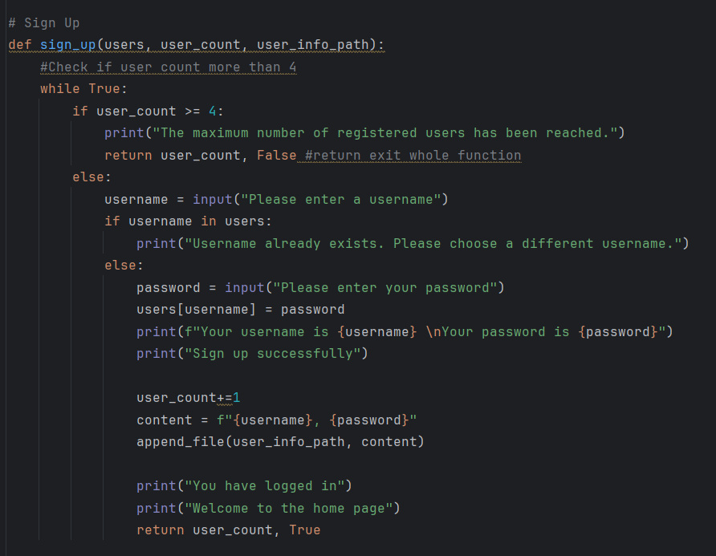
The sign_up function begins by requesting the parameters “users”, “user_count” and “user_info_path”. Next, it checks whether the number of users has reached the maximum number allowed, which is 4. If so, the program prints an error and exits this function.

If the number of users is below 4, it will prompt for a username and check whether it exists in “users”. Assuming it does not exist, the user will need to enter a password to successfully register. After that, the user_count variable increases by one and the user details are appended to the text file.

The user will be redirected to the home page if the sign-up is successful.

2.4 Login Function
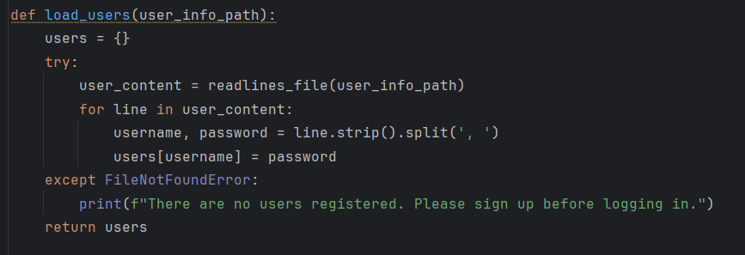
The login function begins by defining a function called “load_users” to load the user details from the text file. The program will remove the empty spaces and split the username and password inside the text file and assign them to their respective variables, “username” and “password”. However, if the text file is not found, the program prints that there are no users registered and asks the user to sign up before logging in.

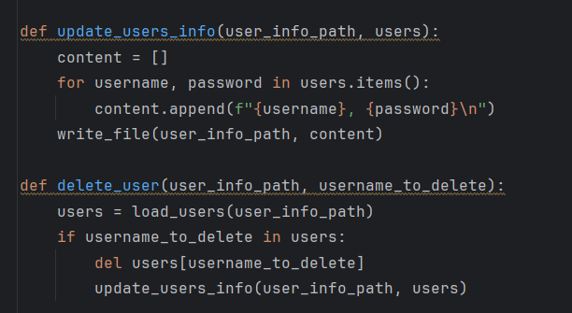
Next, two functions are defined together, which is the “update_users_info” and “delete_user” function. The first function appends the username and password into an empty list. The second function loads user details from the text file and deletes them if the username is in the text file.
Overall, both functions are to be called when user login attempts exceed 3 times, in which the user details will be deleted from the database.

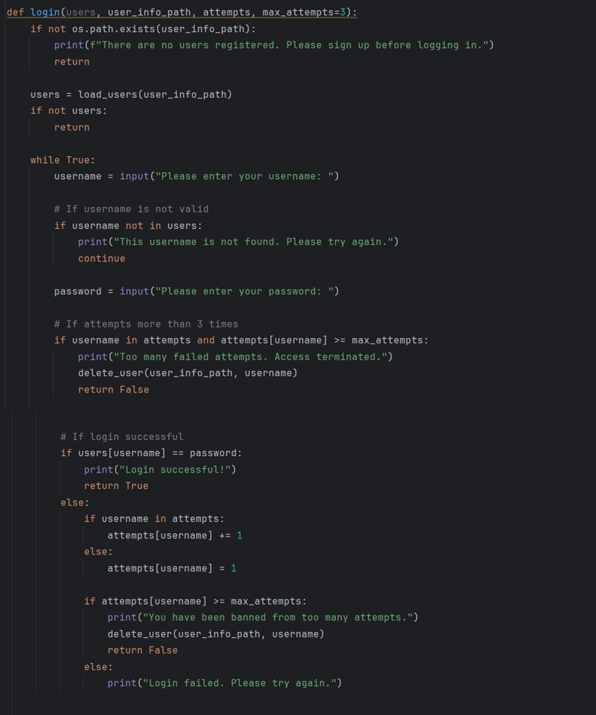

Finally, the main login function, login() is defined. It starts by checking whether the text file path exists or not. If it does not exist, the program exists from the login function as there are no users registered.

If it exists, the program loads the user details from the text file into a variable named “users”. It then prompts users for their username. If the username is not in “users”, it prints an error and one count is added to failed username attempts, while asking the user to retry. If the username is found, it asks for the password.
If the failed username attempts exceed the max attempts limit, the user is terminated from the program.

However, if the failed username attempts are below three times, the program then verifies the password of the specific user. If it matches, the program will log the user in and skip this function. If it does not match, it checks whether the amount of login attempts from this user exceeds the limit and terminates their access if so. If user access is terminated, their account details are removed from the database.

2.5 Read, Write, Append Files Function
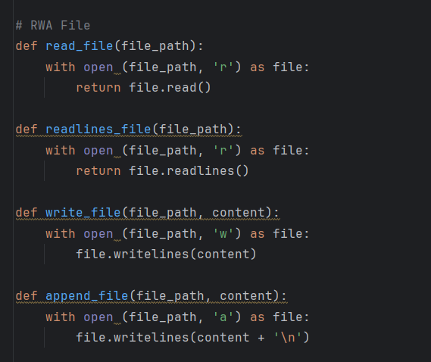

The above functions are used to simplify the process of opening files.
The function “read_file(file_path)” opens a file in read mode and read the first line.
The “readlines_file” function opens a file in read mode and read every line of the file.
The “write_file” opens a file in write mode, or “w”, and writes a content inside the file.
The “append_file” function opens a file in append mode, or “a”, and append lines to the bottom of files.

2.6 PPE File Function
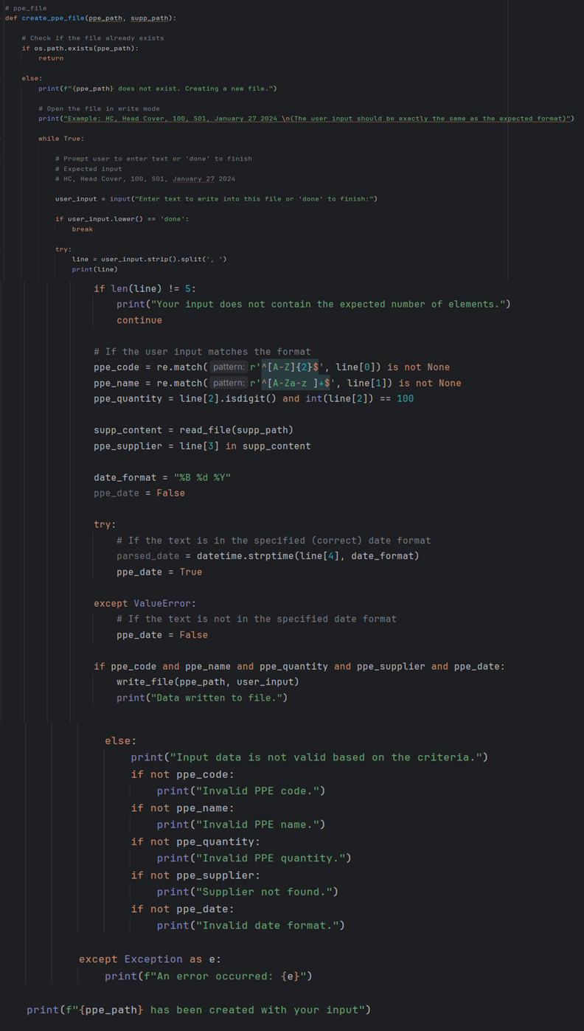
First, the program defines the “create_ppe_file” function and begins by checking whether the ppe_path exists or not. If it exists, the function ends (which represents that the program has been run before). If it does not exist, a new file is created and opened in write mode (which occurs when the program is run for the first time). It then prompts the user for input and provides a format for data to be inputted in. Once the user is done inputting data (according to the specific format), they can input “done” to end the prompt. Content inside ppe_file can only be “write” into at this beginning stage, users wont be be able to add values into ppe_file anymore after input “done”.

The program then checks the input by removing the empty spaces and splitting them into multiple parts and checks whether each line has exactly 5 elements. If not, it proceeds to check the errors one by one. The “ppe_code”, “ppe_name” and “ppe_quantity” is checked to match a predefined format. For example, the “ppe_code” is checked whether it starts with two capital letters, the “ppe_name” is checked for whether it starts with a capital letter and ends in non-capital letters and the “ppe_quantity” must be a digit ending in 100. The “supp_path” file is then set into read mode under the “supp_content” variable. The “ppe_supplier” variable is set to the fourth line in “supp_content”, which verifies the existence of the supplier code. After that, the date format is set to %B $d $Y which represents month, day and year.

Once all the variables are valid and following the correct format, all of them will be inserted into the file. If any of them does not follow the criteria, the respective variables will be highlighted and printed for the user to correct.

2.7 Supplier File Function

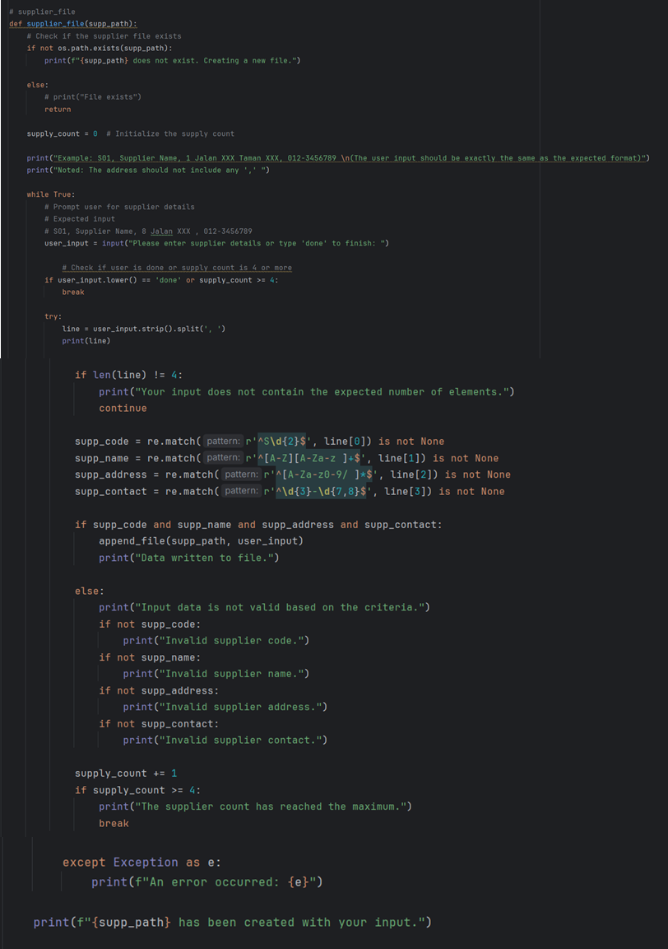

Similarly to the ppe file function, the supplier file function begins by checking whether the supplier_path exists or not. If it does not exist, a new file will be created, or skipped if it exists.

The variable supply_count variable is initialized as 0, which will keep track of the number of suppliers later on. Next, the program prompts the user to input the supplier details following a format. Once the user is done or the supply_count is more than or equals to 4, the data inserted will be broken down and their formatting will be checked. The supp_code variable will be checked whether it starts with S followed by two digits. The supp_name variable will be checked whether it starts with a capital letter, followed by non-capital letters. The supp_address can only have numbers and letters. The supp_contact will be checked whether it starts with 3 numbers, followed by a hyphen, then followed by 7-8 digits.

Once all the details are confirmed to be following the format, all details will be appended into the supplier text file. If any of them are not following the format, they will be broadcasted to the user and asked to reinput the details. Each line of detail being inserted will add one to the supply_count and when it exceeds 4, the function will end.

2.8 Hospital File Function
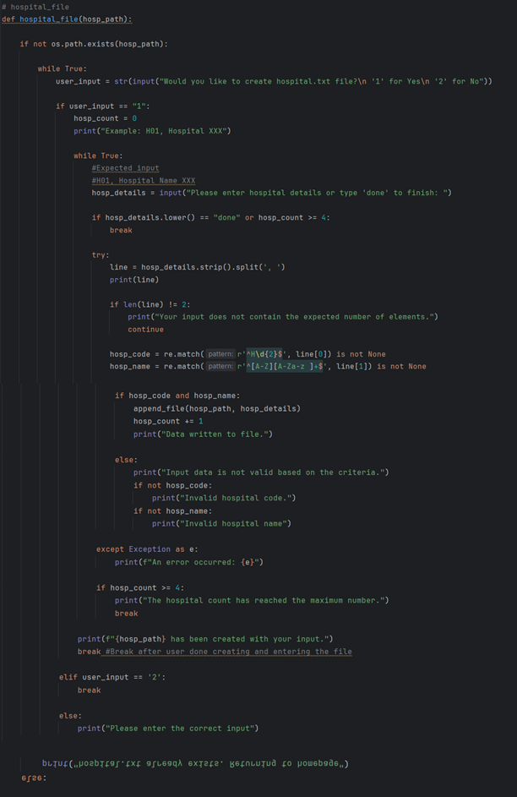
The program defines a function “hospital_file”. First, it checks whether the hospital path, or hosp_path exists or not. If it already exists, the user will be notified and sent back to the home page. If it does not exist, the user will be asked whether they would like to create a hospital file. If the user wants to create a hospital file, the hosp_count which keeps track of the number of hospitals is set to 0. The user is then prompted to input hospital details. Once the user is done or the number of hosp_count is more than or equals to 4, the prompt will end. The inputted hospital data will have its empty spaces removed and split and the format is checked. If the length of the lines is not equal to 2, the program will analyze the error by checking the format of the hospital code and name.

If both data inserted is correct, the hosp_name and hosp_code will be appended into the hospital text file and the hosp_count will be increased by 1.

If either one of the data produces an error, that specific data will be highlighted and displayed to the user to be reinputted.

2.9 Distribution File Function
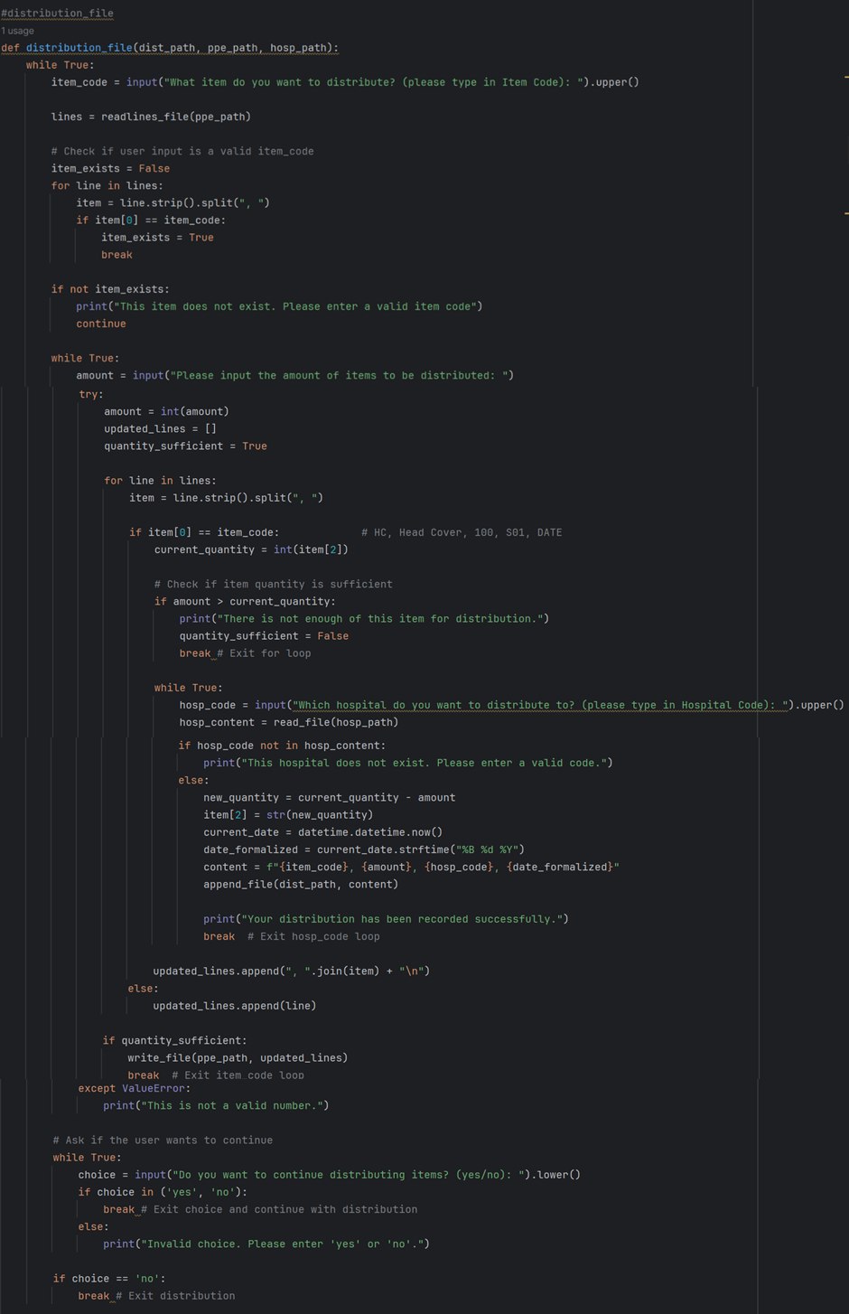
The function distribution_file() has been defined. This function handles the distribution of PPE items to various hospitals. It has three parameters: dist_path, ppe_path, and hosp_path.

The function enters an infinite loop, prompting the user to enter the item code of the PPE they want to distribute. What the user enters is stored in the variable item_code.

If item_exists is False, meaning that the item code does not exist in the inventory, an error message is returned. The user is prompted to re-enter the item code and continue the outer loop.

If item_exists is True, the function enters another loop, prompting the user to enter the quantity of the item to be distributed. The input is stored in the variable amount. The program attempts to convert amount to an integer. If the conversion fails, an error message is displayed. The user is prompted to enter the amount again.

If the conversion is successful, the program initializes the empty list updated_lines and the boolean variable quantity_sufficient to True. Then, if the first element of item matches the item_code (which means the item code based on user input is found), the current quantity of the item is stored in current_quantity.

The program checks if the amount to be distributed is greater than the current_quantity. If yes, an error message is displayed, and quantity_sufficient is set to False. The loop breaks.

If not, the quantity_sufficient will set True, the program enters another loop, prompting the user to enter a hospital code. The input is converted to upper case and stored in the variable hosp_code. The hospital file is read using read_file(hosp_path) and the contents are stored in hosp_content.

The program checks if hosp_code exists in hosp_content. If not, an error message is displayed (which means the hospital code which input from user is not valid), and the user is prompted to enter the hospital code again.

If it exists, the new quantity of the item is calculated by subtracting from hosp_code, and the new quantity is updated in the list. The current date and time are obtained using datetime function and the date is formatted to “%B %d %Y. A distribution record is created using, , and it is appended to the distribution file using . A success message is displayed, and the loop breaks.

The updated item details are appended to the updated_lines list. If the quantity_sufficient flag is True, the updated inventory is written back to the PPE file using write_file(ppe_path, updated_lines). The loop for the item code will break.

The program asks the user if they want to continue distributing items. The input is stored in the variable choice. If the user enters "yes" or "no", the loop will break. Otherwise, an error message is displayed, and the user is prompted to enter "yes" or "no" again.

If the user chooses 'no', the outer loop will break, and the function ends.

2.10 Distribution Hospital Function
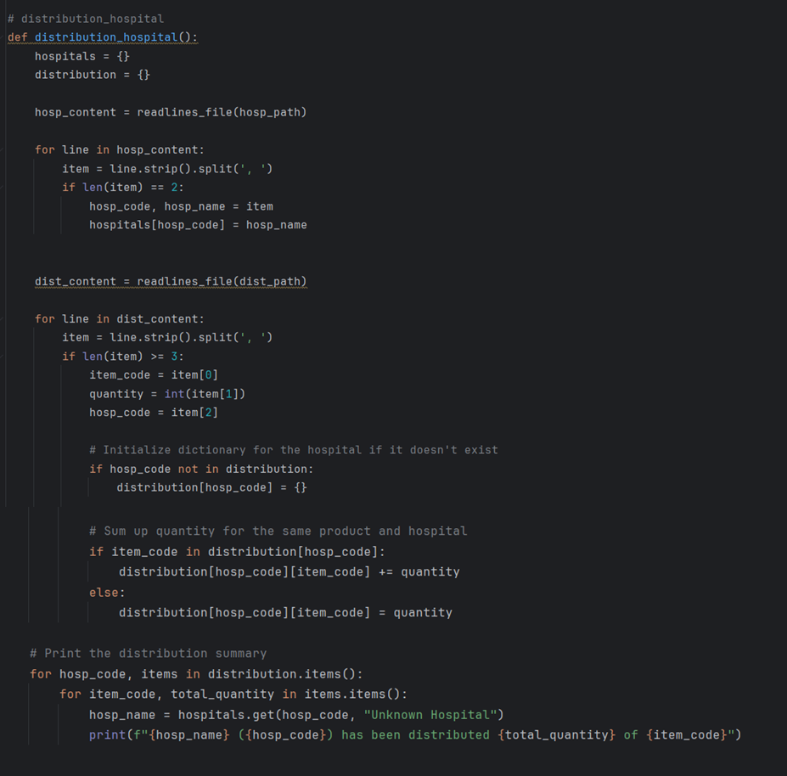

The distribution_hospital() function is defined. Two variables, “hospitals” and “distribution” is set as empty dictionaries. The hospital path text file and distionary path text file is set to read mode.
The program then removes empty spaces and splits the data in hosp_content, saved in a variable called “item” and checks their length. If the length equals to 2, hosp_code and hosp_name is set as “item”.

The program removes empty spaces and splits each line in dist_content and checks for its length. If the length is more than or equal to 3, each split element in dist_content is respectively set to “item_code”, “quantity” and “hosp_code” variables.

Next, the program initializes a dictionary for the hospital if it does not exist.
After that, it sums up the quantity for each product in each hospital and prints them in a report form.

2.11 Update Inventory Function
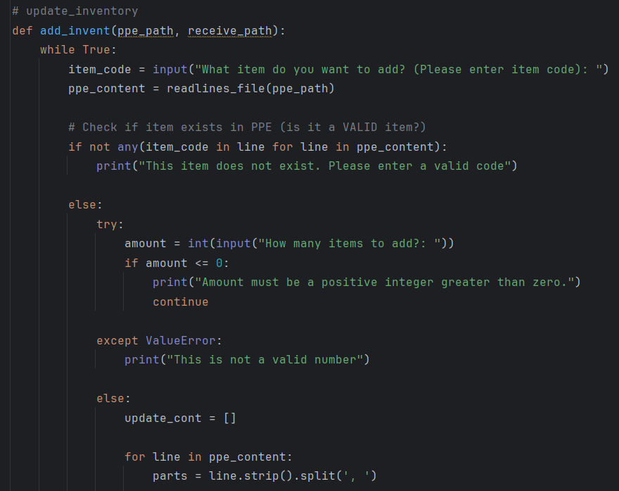

To add a certain number of things to an inventory, The add_invent(ppe_path, receive_path) function is used to add a certain quantity of items to the inventory. The function will continuously ask the user to enter an item code (while True) at the beginning. After that, it will see if the file at ppe_path has this item code. If the item code is not found, it prompts the user to enter a valid code. If the item code is found and valid, it then prompts the user to enter a positive integer number of items to add. If the input for the amount is invalid, it prompts the user to input again.
After valid inputs are received, each line in the PPE file is split into parts.

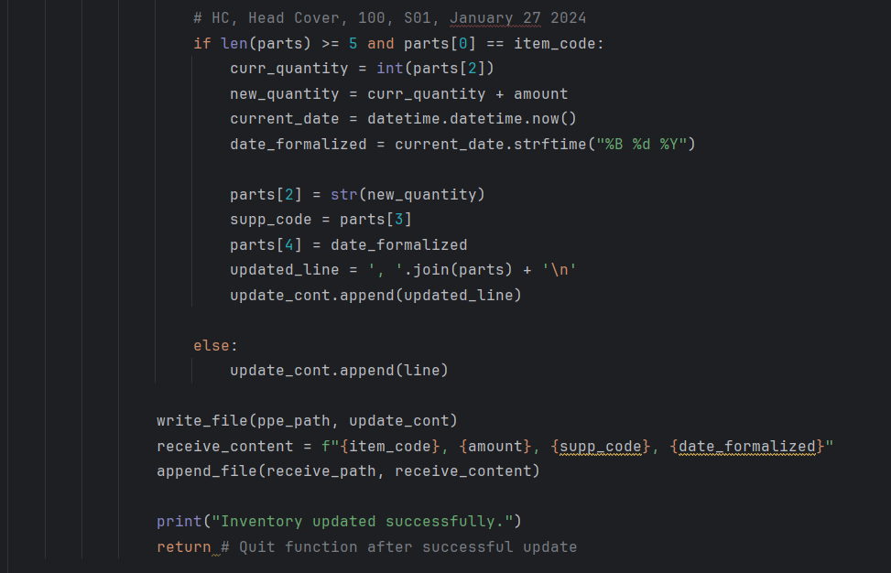
After ppe_content is split successfully, the function checks if the length of the input line has at least five parts and check if the first part is the same as the item code that user input. If yes, the function adds the specified amount of the item and sets the current date. The updated line is then appended to the list of updated_line, while unchanged lines are also appended into this list. If the length of parts is not equal to 5 or the first part is not the same as the item code that user input, the function appends the unchanged line to the update_cont list.

After processing of all lines is completed, the function writes the updated lines back to the PPE file, logs the transaction details (item code, amount, supplier code, date) to the reception file. Then, a message is printed informing the user of the success of updating inventory. Finally, the function will be exited.

2.12 Distribute Inventory Function

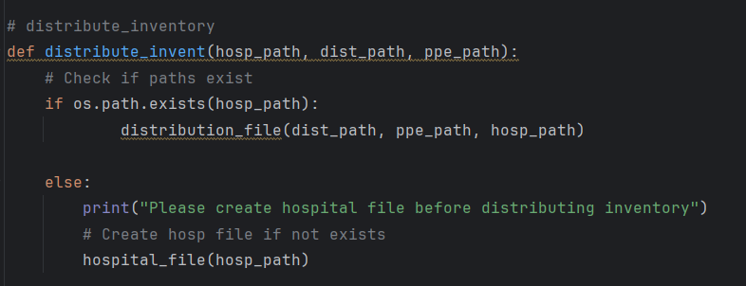

The distribute_inventory function starts by checking whether the hosp_path variable exists. If it does not exist, the user will be asked to create a hospital file before distributing the inventory, in which they will be linked to the hospital_file function. If it exists, the function “distribution_file” will be called.

2.13 Update Supplier Function
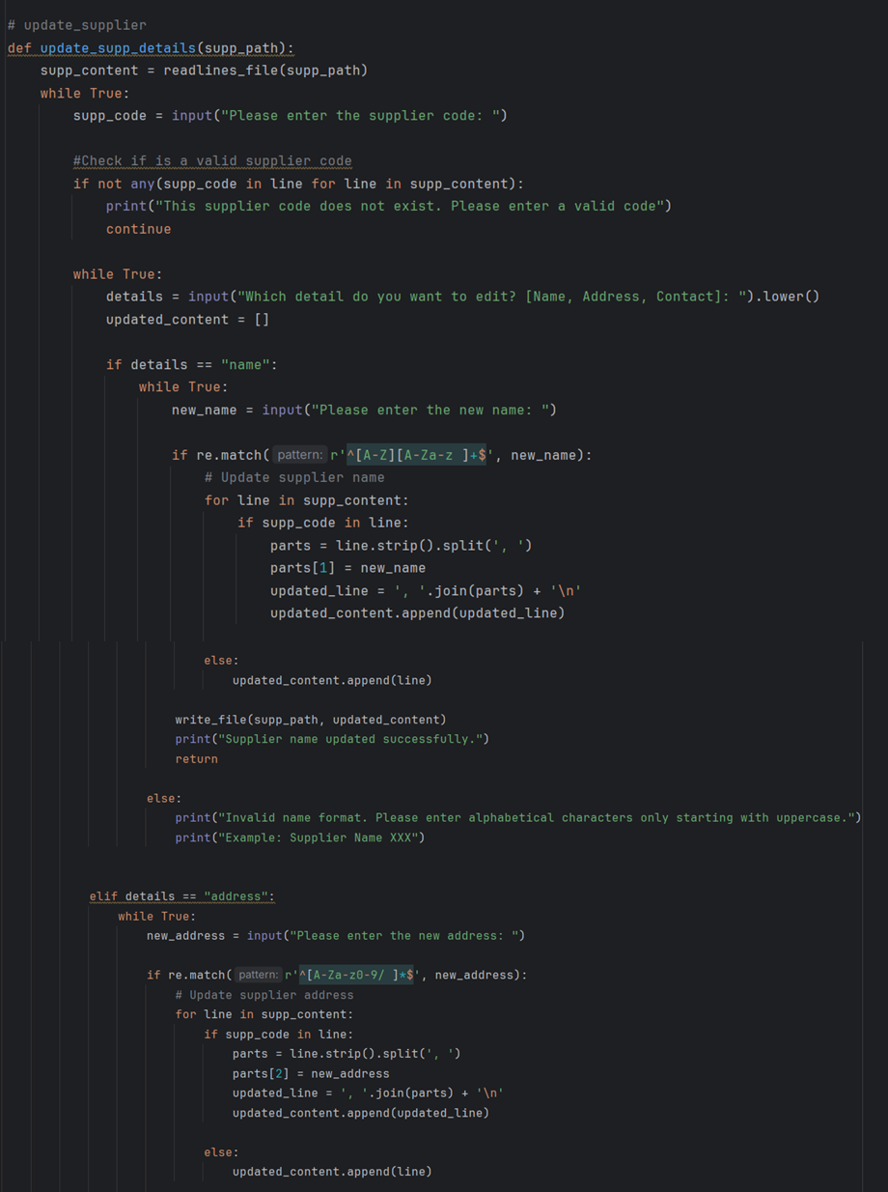


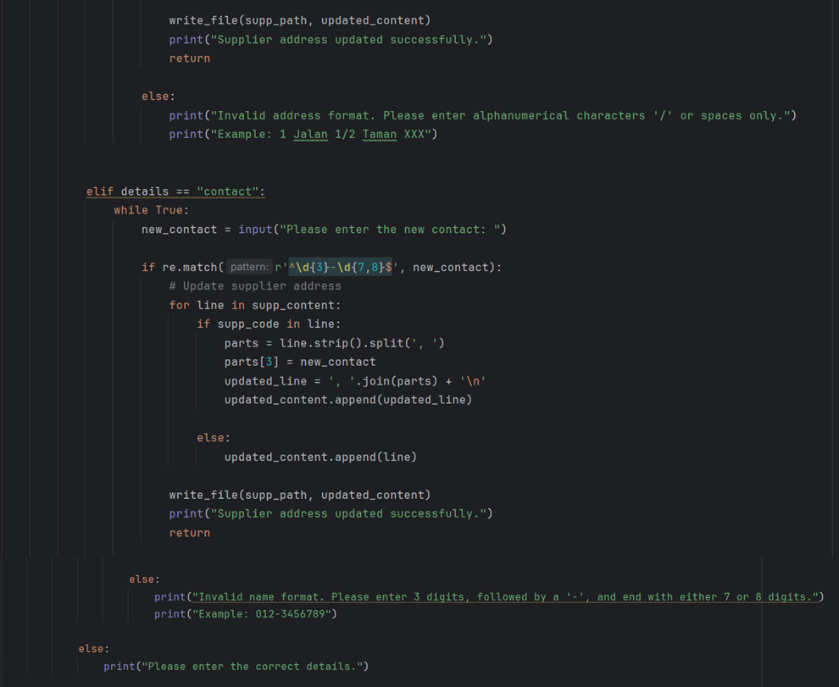

The `update_supp_details` function is used to update supplier information in the supplier file. First, it reads the file's content and will prompt the user to enter a supplier code. Then, the function will verify if the code exists in the file. If the code isn't found the function will prompt the user to enter a valid code. This process will be looped until a valid supplier code is input.

Once a valid code is entered, the function will proceed and asks the user which detail you want to edit name, address, or contact. For each choice, the function will execute a verification process for the new information the user provides, where all this happens in a loop. For example, if the user chooses to update the name, it ensures the new name starts with an uppercase letter and contains only letters and spaces. If you choose to update the address, it checks that it contains only letters, numbers, slashes, and spaces.

After that, if the new detail entered is valid, the function updates the relevant line in the file and saves the changes. Then, a message will be printed informing users that these details have been updated successfully.

2.14 Update Hospital Function

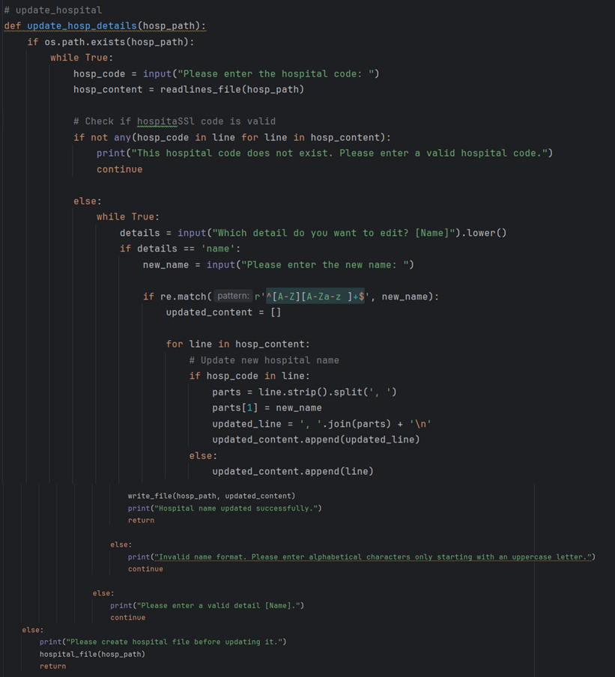

The update_hosp_details (hosp_path) function is to update existing hospital details. To update hospital details, there must be at least one hospital file created. If there is none, a message “Please create hospital file before updating it” will be generated and redirect to the hospital_file function to create it.

If the hospital file exists, user will be first prompt to enter hospital code. Then, the function checks if the hospital code exists in the file. If it does not exist, it will print a message indicating that the input is invalid, and the user will be prompted again to enter a valid hosp_code. This loop will repeat until a valid hosp_code is given by the user. Once a valid code is entered, it prompts the user to specify which detail to edit, which for now, user can only edit hospital name. Then, they are to enter a new name, which must follow a certain format, such as the new name must start with an uppercase letter and contain only letters and spaces. If the new name does not match the required format or the input entered is not a “name’, the user is prompted to enter a valid name again and the loop will continue. If the new name matches this condition, the function prepares to update the hospital's details in the file.

Then, the function continues by executing a nested “if” statement. For each line in the hospital file, it checks if the line contains the hospital code. If yes, the line is split into parts where the name part is updated with the new name, and the new line is appended to the updated_content list.

If the line does not contain the hospital code, the functions append the line the updated_content list without any changes. After this, the function writes the updated content back to the file and prints a success message.

2.15 Track Items Function
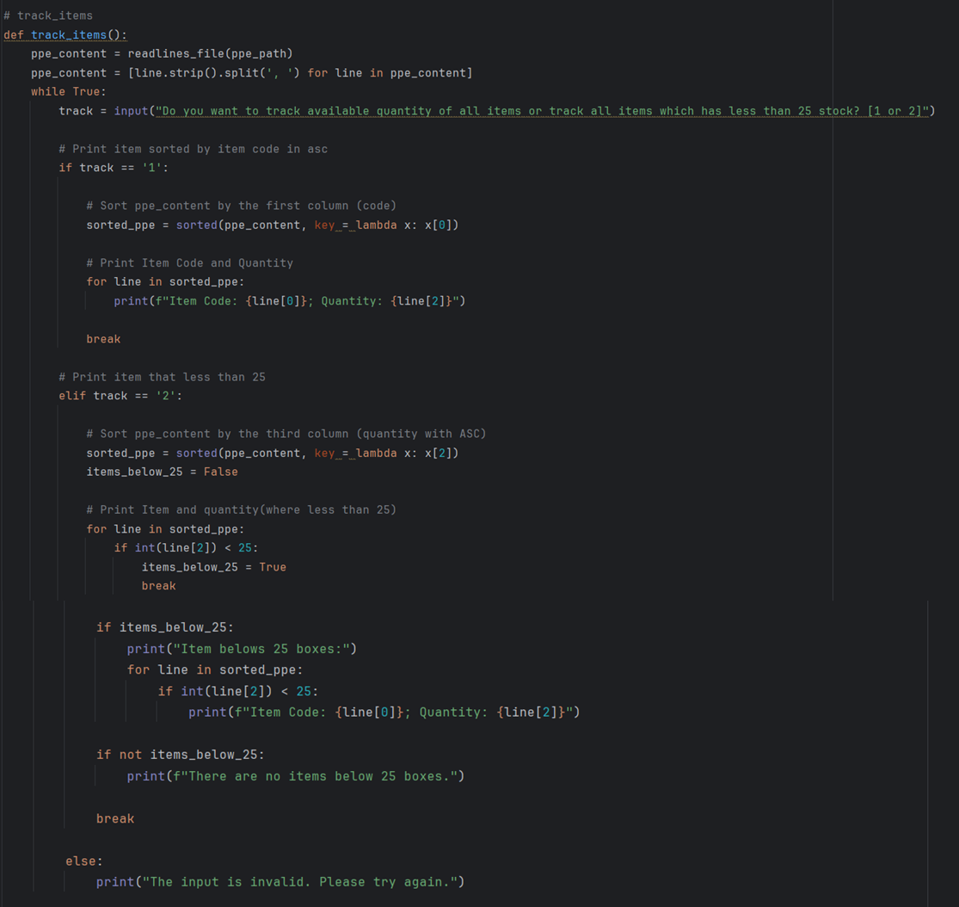
The function begins by reading all lines in the ppe_path file, removing empty spaces and splitting them. Then, it prompts the user to choose between tracking the available quantity of all items or tracking all items below 25 stocks. If the user chooses to track the available quantity of all items, the element in the file is sorted in ascending order by first element. After that, the program prints the sorted items by code and quantity.

If the user chooses to track all items below 25 stocks, the program sorts the elements in ascending order by quantity (which is the third element). Then, it filters out the items which quantity is below 25 and lists them down. If there are no items below 25 stocks, it will notify the user.

2.16 Search Distribution Function
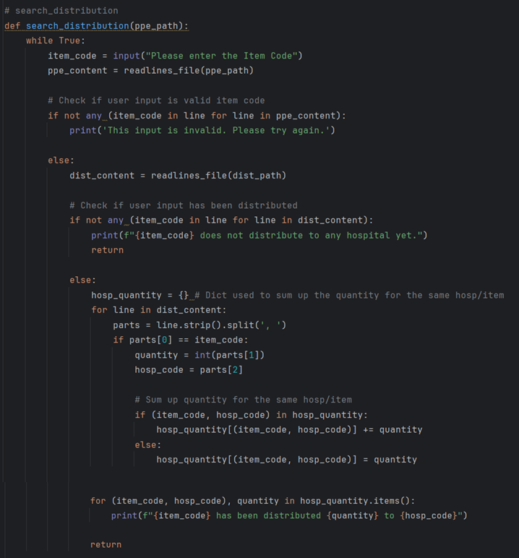

The function begins by prompting the user to input the item code and reading all lines in the ppe_path file. If the item code is not found in the file, an error willl be printed. If the code is found, the program will read all lines in dist_path.

Next, it checks whether the item input by the user has been distributed to a hospital or not. If it has been distributed to a hospital, the items in the file will have empty spaces removed and split. If the items have been distributed to more than one hospital, the program sums up the items by adding them together. If it has only been distributed to one hospital, the item quantity distributed will remain unchanged.

2.17 Suppliers with PPE Function
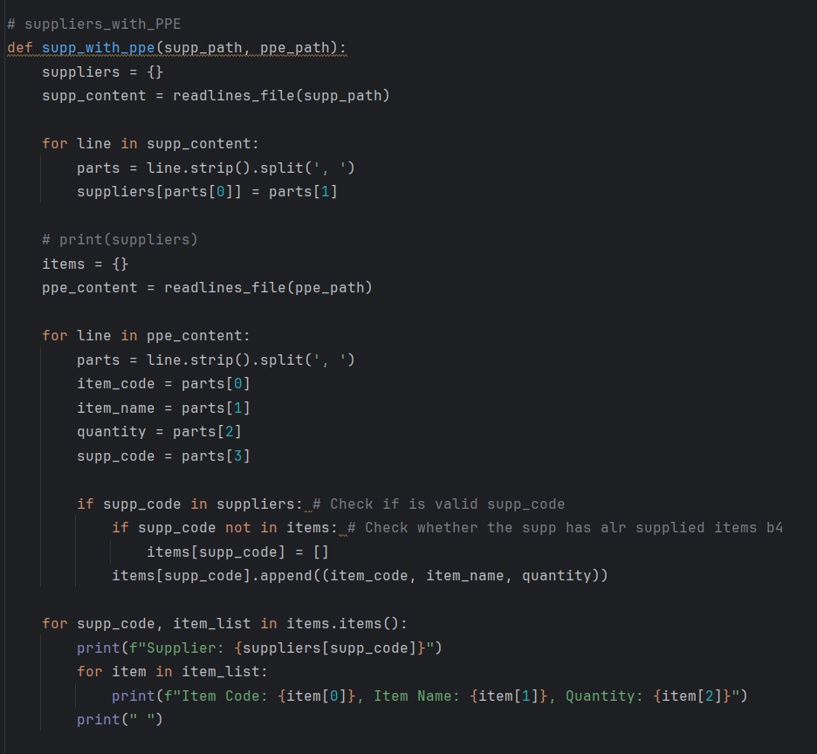

The function above initializes an empty dictionary “suppliers” and reads all lines in the file “supp_path”. Then, the lines in the file will remove all whitelines and are split. The supplier_code from the file is stored as the key and the suppllier_name is then stored as the value in the “suppliers” dictionary.

Next, an empty dictionary “items” is initialized and all lines in “ppe_path” is read. The whitelines in the file is removed and split. The item_code, item_name, quantity and supp_code from the file will then be inserted into the dictionary “items” as slot 0, 1, 2, 3 respectively.

The supplier code will be validated by checking if it exists in “suppliers” dictionary. If it exists and is not already in “items” dictionary, a new list will be made for that supplier code. The item details for that supplier code will then be appended into the “items” dictionary.

Finally, all the details of suppliers and their item details are printed.

2.18 Overall Transaction Function
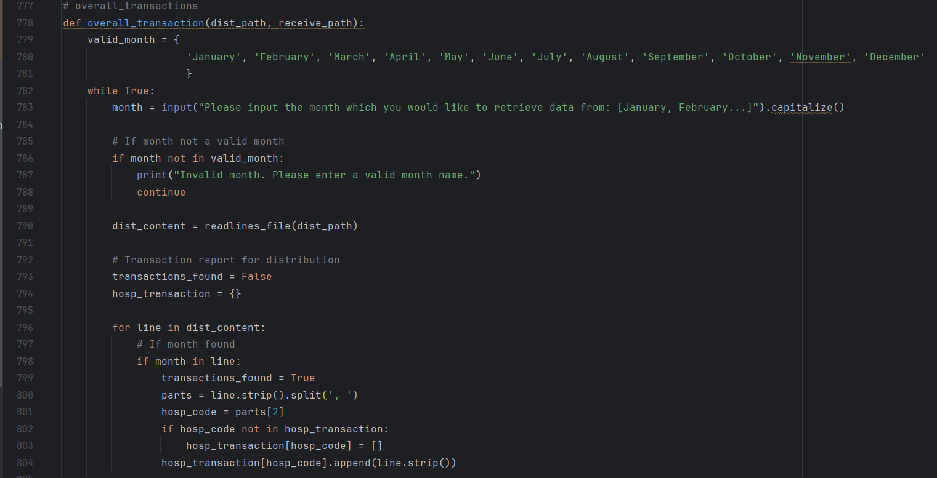
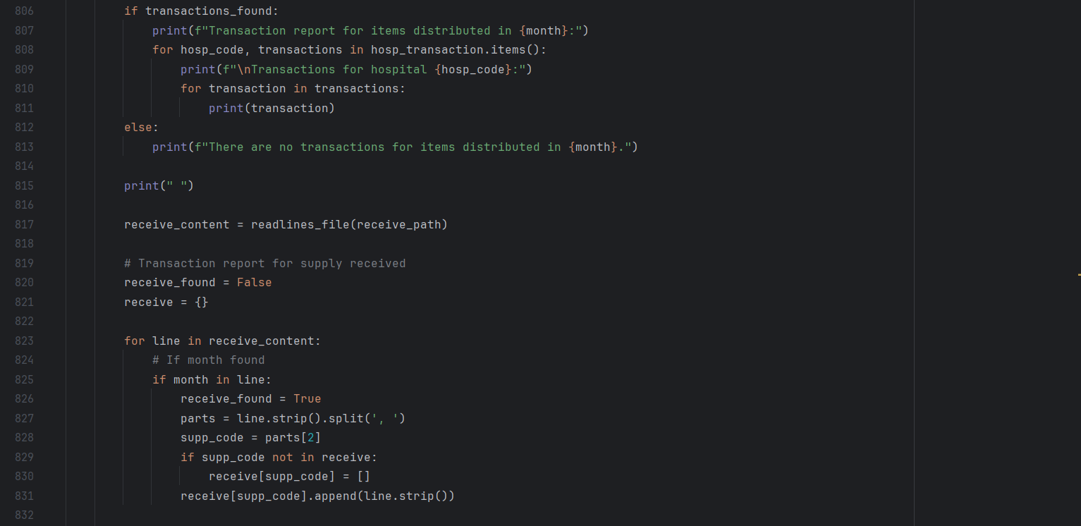
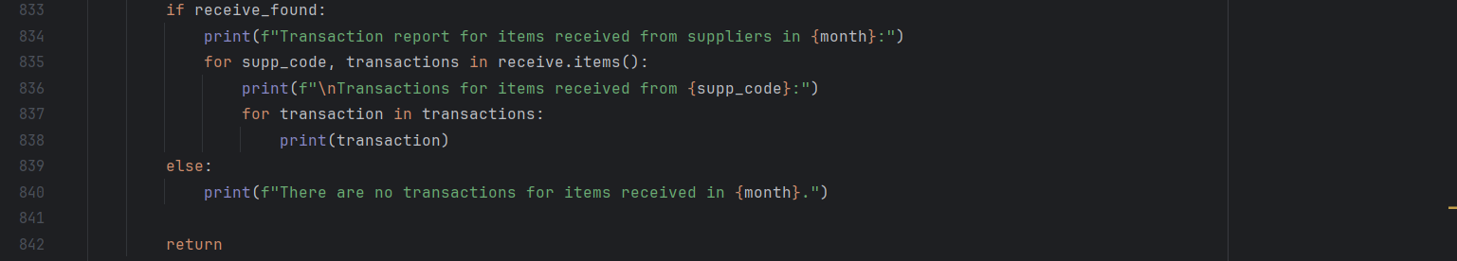

The function overall_transaction() is defined. The collection valid month contains valid month names and is used to validate user input. The function then enters a loop that prompts the user to enter a month and ensures that the user input is valid by checking valid month.

If the month is valid, the function reads the distribution file contents using readlines_file(dist_path) and initializes two variables: transactions_foundasFalse and hosp_transactionas as empty dictionary.

The program then sets transactions_found to True if it finds the specified month in a row and extracts the hospital code. If the hospital code does not exist in hosp_transaction, it is added as a key with an empty list as its value. Each matching transaction row is appended to the corresponding list of hospital codes.

If a transaction is found, the program prints a report of items distributed in the specified month, grouped by hospital code. If no transaction is found, a message is displayed indicating that there were no transactions for that month.

Next, the function reads the received supplies file contents using readlines_file(receive_path) and initializes two variables: receive_foundas as False and receives as empty dictionary.

The program then sets receive_found to True if the specified month is found in a line and extracts the supplier code. If the supplier code does not exist in receive, it is added as a key with an empty list as its value. Each matching transaction line is appended to the corresponding list of supplier codes.

If the received supplies are found, the program prints a report of items received for the specified month, grouped by supplier code. If the supplies received are not found, a message is displayed indicating that there were no transactions for that month. After generating and printing the report, the function exits

2.19 Home Function & Code
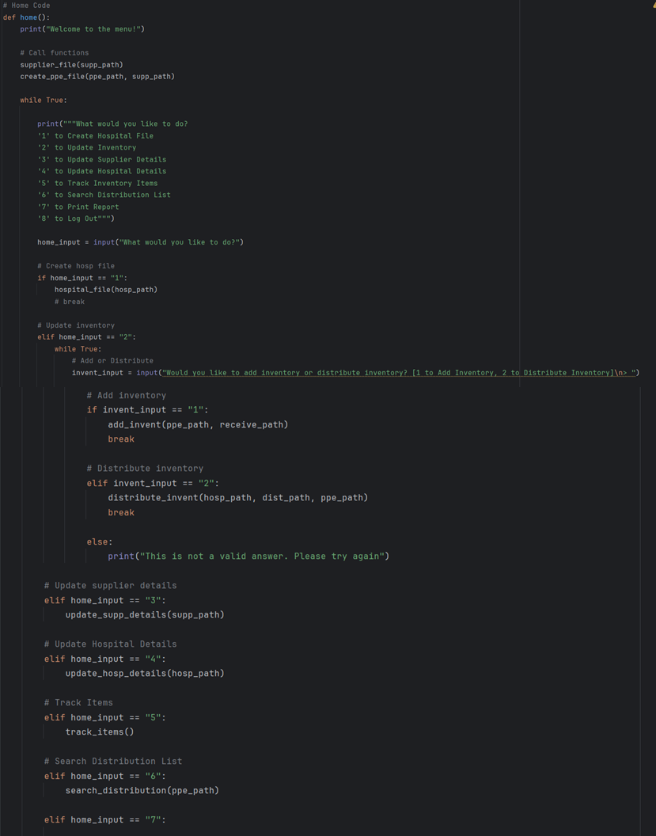
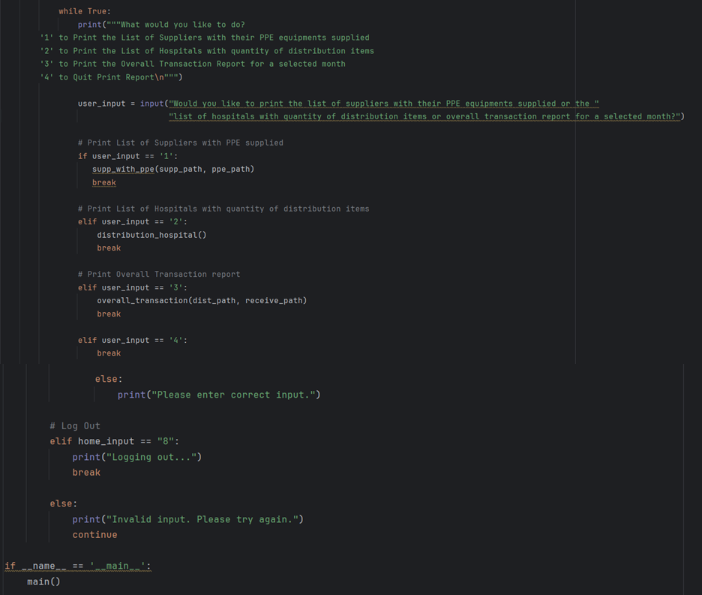
Lastly, the “home()” function is defined. The functions supplier_path and create_ppe_path is called to initialize the text fils beforehand as both functions are crucial to the execution of the code. After that, the user is prompted to choose among 8 choices, including creating hospital file, updating inventory, updating supplier details, updating hospital details, track inventory items, search distribution list, print reports or log out.

If the user chooses to create hospital file, “hospital_file(hospital_path)” function is called.

If the user chooses to update inventory, they will be prompted again to add to the inventory or distribute inventory. If the user wants to add inventory, “add_invent(ppe_path, receive_path)” function is called. If the user wants to distribute inventory, “distribute_invent(hosp_path, dist_path, ppe_path)” is called.

If the user chooses to update supplier details, the function “update_supp_details(supp_path)” is called.

If the user chooses to update hospital details, the function “update_hosp_details(hosp_path)” is called.

If the user chooses to track inventory items, the function “track_items()” is called.

If the user chooses to search distribution list, the function “search_distribution(ppe_path)” is called.

If the user chooses to print reports, they will be prompted further to select which report to print. If the user chooses to print the list of suppliers with their PPE equipment supplied, “supp_with_ppe(supp_path, ppe_path)” function is called. If the user chooses to print the list of hospitals with quantity of distribution items, “distribution_hospital()” function is called. If the user chooses to print the overall transaction report for a selected month, “overall_transaction(dist_path, receive_path) function is called. If the user chooses to quit, the loop will be exited.

If the user chooses to log out, the function ends.

If the user chooses none of the options above, an error will occur and the user will be asked to reinput their choice.

Finally, the last two lines of the code represents a built-in Python variable “__name__” which will be set to __main__. This checks whether the script is run directly or being imported in which the output will be “True” or “False” respectively. If the output is “True”, the function “main()” will run.

3.0 Sample Input/Output with Explanation

Logging In

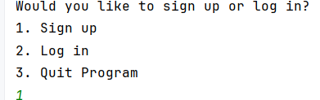

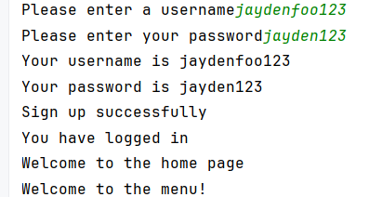

At the start of entering our inventory management system, you have an option to sign up or log in.
In this example, ‘1’ is the input, which means I would like to sign up. Therefore, my username
is “jaydenfoo123” and password is “jaydenfoo123”. After signing up is successful, the system
will automatically log you in and you be directed to the home page.

Creating Supplier File

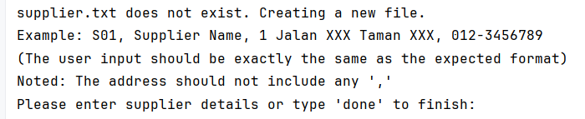

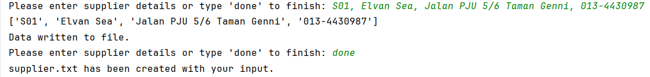

For the first time user or first logged in, at least one supplier.txt must be created, where maximum 3 to 4 suppliers can be added. To input supplier.txt, the expected format must be followed as given by the example provided. After the first successful input, you can proceed to input another 3 more. If you are done, you can input “done”. Then, an output will be printed indicating that supplier.txt has been created successfully.

PPE File Creation

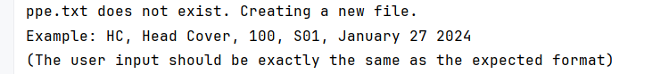

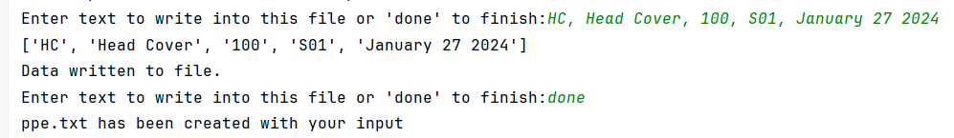

Similarly, upon a user first time logged in, at least one ppe.txt must be created. To input supplier.txt, the expected format must be followed as given by the example provided. If you are done, you can input “done” and an output will be printed indicating that ppe.txt have been created successfully. After that, you will be directed to the homepage for further actions to be performed.

Home Page - Option 1

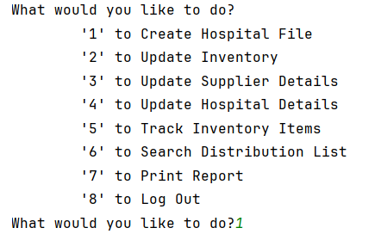

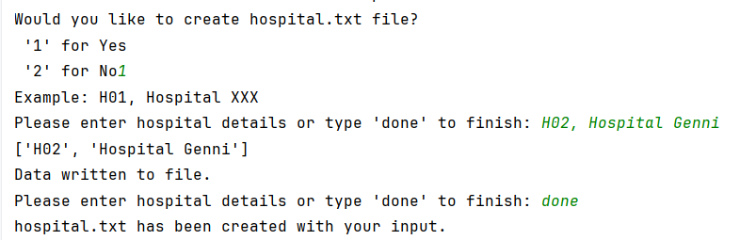

There are 8 options that can be performed on the homepage. When the user is prompt “What would you like to do”, user will input any number from 1-8, which as above, I input “1”. Option “1” is to create hospital.txt file, where user is required to enter the respective hospital details based on the given format. When user is finished, “done” must be the input and an output will be printed indicating that hospital.txt have been created successfully.

Home Page - Option 2

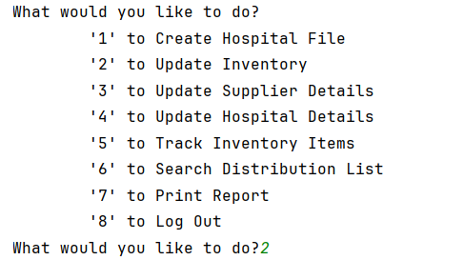

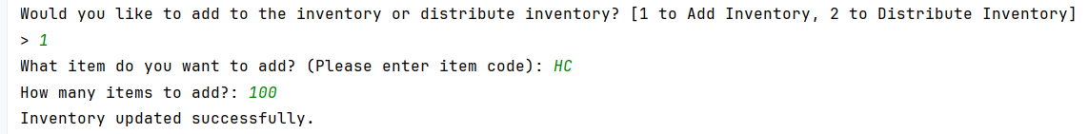

If the user selects option ‘2’ to update inventory, user will have the option to add inventory or distribute inventory, each represented by ‘1’ and ‘2’ respectively. In this example, I input option ‘1’ to add inventory, where I am required to enter item code and input quantity of items to add. Then, an output indicating that inventory is updated successfully will be printed.

Home Page - Option 3

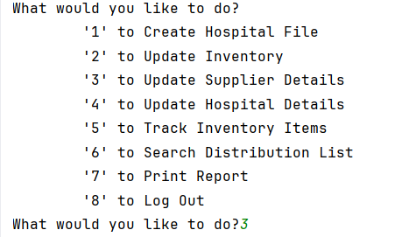

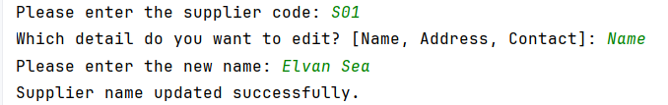

If the user selects option ‘3’ to update supplier details, user will first need to enter supplier code. From here, users will have to input what they would like to edit, either name, address or contact. In the example above, names have been selected to be edited. Then, the new name will be the input and an output indicating that supplier name has been updated successfully will be printed.

Home Page - Option 4

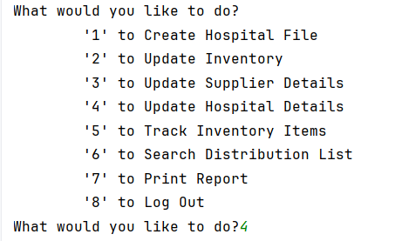

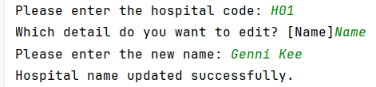

When a user input option ‘4’, they can update hospital details. Users will first need to enter hospital code. From here, users will have to input the hospital code and detail that the user likes to edit. Then, the new name will be the input and an output indicating that the hospital name has been updated successfully will be printed.

Home Page - Option 5

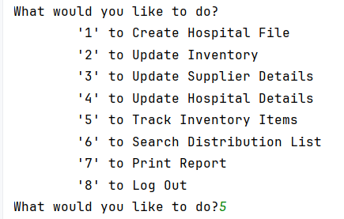

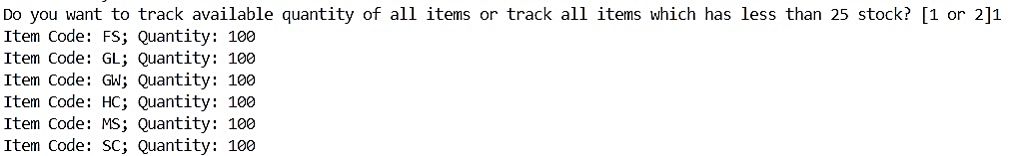

Option “5” can be initiated to track inventory items. When user input ‘5’, they need to choose to either track all available quantity or track inventory that have less than 25 in stock, both with “1” and “2” assigned respectively.

Home Page - Option 8

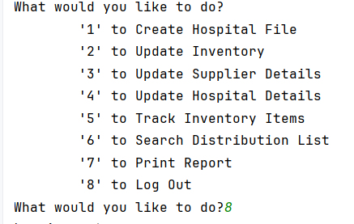

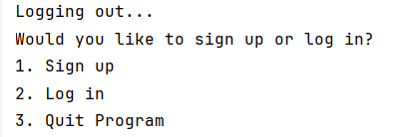

To quit or log out, user must input “8”. Then, the system will print an output “logging out”. By then, the user will be redirected to the signup/login page where they have the option to log in again. At this page, they can input ‘3’ to quit the program completely.

4.0 Screenshots of Text Files

PPE File (ppe.txt)
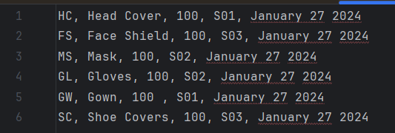

User Info File (user_info.txt)
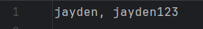

Supplier Info File (supplier.txt)
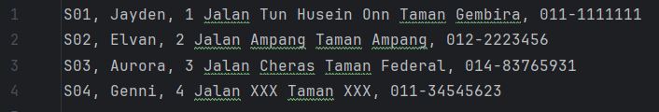

Hospital Info File (hospital.txt)
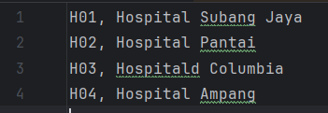

Distribution File (distribution.txt)
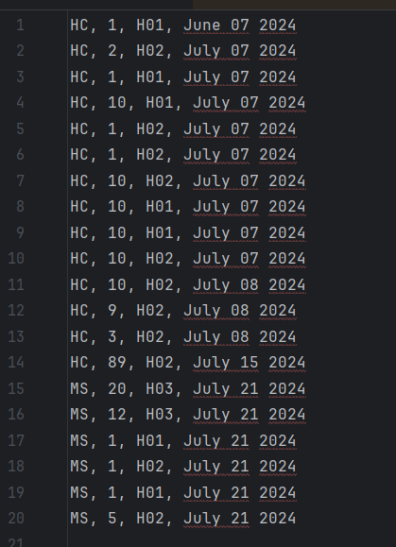

Supply Received File (receive_supply.txt)
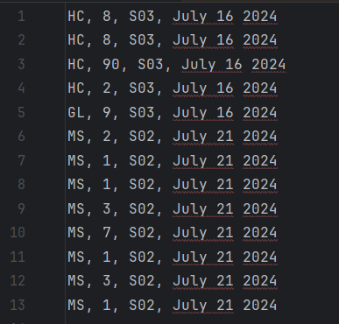

5.0 Conclusion
In conclusion, the Personal Protective Equipment (PPE) Inventory Management System has been successfully developed. This system has met the requirements of the Ministry of Health and effectively manages the inventory of PPE items received from multiple suppliers and distributed to various hospitals. The main features of the system include:

1. Secure Login Functionality
The system ensures that only authorized inventory controllers can access and manage inventory, and they can make up to three login attempts. In this way, the system’s security can be increased.

2. Initial Inventory Creation
During the first execution, the system initializes the inventory with a predefined number of PPE items. The user is prompted to enter details and store the information in ppe.txt.

3. Inventory Update
This system allows for seamless inventory updates, including receiving new supplies and distributing PPE items to hospitals. Before distributing PPE, it verifies that there is sufficient stock available.

4. Inventory Tracking
The program can print the total available quantity of all items sorted by item code. Additionally, it identifies items with fewer than 25 boxes in stock for efficient inventory management.

5. Search Functionality
The system provides details about the hospital code and the number of distributions. As a result, users can search for the distribution history of a specific product by item code.

6. Report Generation
A variety of reports are generated, including a list of suppliers with their items, hospitals with their quantity distribution of items that received from suppliers, and overall transaction report for the selected month.
Throughout the development process, we adhere to good programming practices such as modular design, proper use of functions, and comprehensive validation. We have tested the system and made sure that the system can handle both valid and invalid inputs, increasing the reliability of the system.

